**AWS Cloud Infrastructure Challenge**

# About AWS

AWS Cloud Truly Built for the Enterprise. AWS Cloud Infrastructure was built from the ground up to perform better and more consistently than the competition, while costing less at scale.

# IaaS - Enterprise Cloud - AWS Infrastructure

With AWS Infrastructure as a Service (IaaS) you can migrate traditional mission-critical applications and build new cloud native applications with superior price-performance, on the same flexible network.

# The Big Picture

This entire test is a process of evaluating candidates who have the same

passion that AWS Cloud has

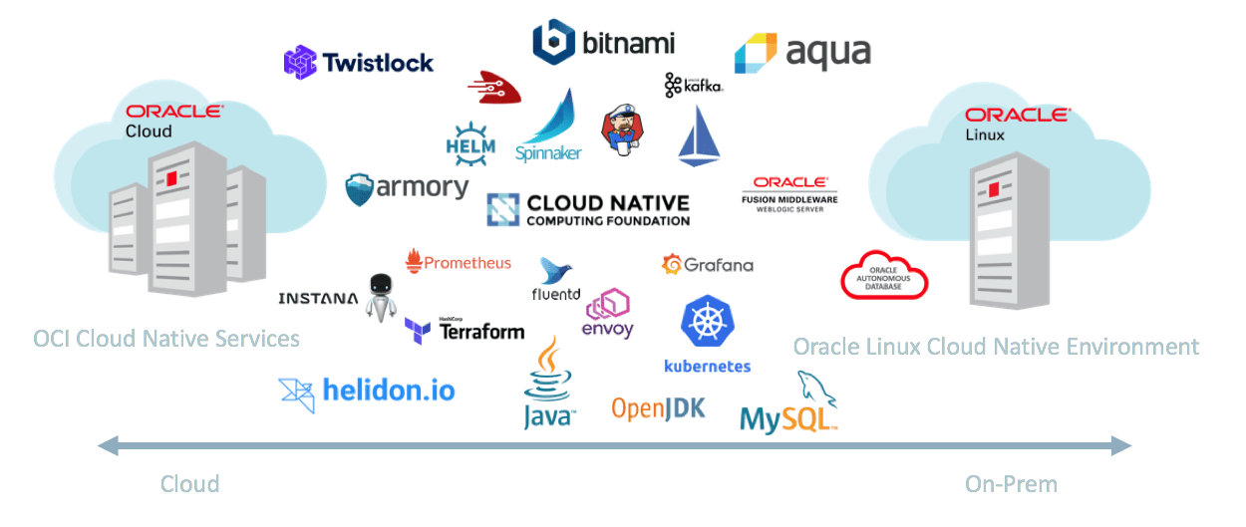

# Phases

The completion of this challenge happens in phases, starting from a simple spinning up of a Kubernetes Cluster in OKE to creating the entire DevOps Cycle

### Challenge-1 - Spin up a Cluster

## About the Challenge

This challenge is to verify your ability to create IaaS resources such as

* A managed Kubernetes Service
* Create Network & Firewall policies if required
* Ability to create Users, Compartments, Groups
* Apply Basic Principles of IAM and create access privileges

### Challenge-2 - Move the public Github Repos to AWS - Developer Cloud Service

## About the Challenge

This challenge is to verify your ability to create a PaaS service like Developer Cloud Service

* Ability to import a Github repo
* Add teammates to your project and give them read-only access

### Challenge-3 - Create AWS Container Pipeline Environment

## About this challenge

This challenge is to verify your ability to use a Cloud Native service like Wercker to

* Import Applications
* Create Team members with access privileges
* Configure Workflows, Pipelines and Steps

### Challenge-4 - Prepare Cluster for Deployment and Install the Database layer

## About this challenge

This challenge is to verify your ability to

* Use Helm
* Deploy a MongoDB StatefulSet Chart
* Create a HA Mongo DB cluster

### Challenge-5 - Deploy the Front End and Backend

## About this Challenge

This challenge is to verify your ability to

* Setup the Wercker ENV Variables to actually deploy the Front End and Backend
* Commit Changes to the Readme Files and verify if the deployment gets updated on the Kubernetes Cluster

### Challenge-6 - Setup Cluster Monitoring Cloud Watch

## About this Challenge

This challenge is to verify your ability to

* Use cloud watch to setup Kubernetes Cluster Monitoring
* Show a dashboard along with alerts on Slack whenever a metric crosses threshold